Statistical Inference- PArt-2

Radha

22 November 2015

This is an R Markdown document. Markdown is a simple formatting syntax for authoring HTML, PDF, and MS Word documents. For more details on using R Markdown see <http://rmarkdown.rstudio.com>.

When you click the **Knit** button a document will be generated that includes both content as well as the output of any embedded R code chunks within the document. You can embed an R code chunk like this:

# Here's a quick analysis of the ToothGrowth data within the R datasets package. The data is set of 60 observations, length of odontoblasts (teeth) in each of 10 guinea pigs at each of three dose levels of Vitamin C (0.5, 1 and 2 mg) with each of two delivery methods (orange juice or ascorbic acid).

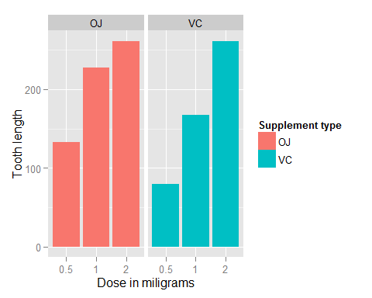

As you have prevously seen, there is a clear positive correlation between the tooth length and the dose levels of Vitamin C, for both delivery methods.

The effect of the dose can also be identified using regression analysis. One interesting question that can also be addressed is whether the supplement type (e.g. orange juice or ascorbic acid) has any effect on the tooth length. Basically, how much of the variance in tooth length, if any, can be explained by the supplement type?

##   
## Call:  
## lm(formula = len ~ dose + supp, data = ToothGrowth)  
##   
## Residuals:  
## Min 1Q Median 3Q Max   
## -6.600 -3.700 0.373 2.116 8.800   
##   
## Coefficients:  
## Estimate Std. Error t value Pr(>|t|)   
## (Intercept) 9.2725 1.2824 7.231 1.31e-09 ***  
## dose 9.7636 0.8768 11.135 6.31e-16 ***  
## suppVC -3.7000 1.0936 -3.383 0.0013 **   
## ---  
## Signif. codes: 0 '***' 0.001 '**' 0.01 '*' 0.05 '.' 0.1 ' ' 1  
##   
## Residual standard error: 4.236 on 57 degrees of freedom  
## Multiple R-squared: 0.7038, Adjusted R-squared: 0.6934   
## F-statistic: 67.72 on 2 and 57 DF, p-value: 8.716e-16

# As you see, the model explains 70% of the variance in the data. The intercept is r fitcoefficients[[1]] units. The coefficient of dose is r fitcoefficients[[2]] units. The last coefficient is for the supplement type. Since the supplement type is a categorical variable, dummy variables are used. The computed coefficient is for suppVC and the value is r fitcoefficients[[3]]) units of decrease in the tooth length. Since there are only two categories, we can also conclude that on average, delivering the dosage as orange juice would increase the tooth length by r abs(fit$coefficients[[3]]) units.

# 95% confidence intervals for two variables and the intercept are as follows.

## 2.5 % 97.5 %  
## (Intercept) 6.704608 11.840392  
## dose 8.007741 11.519402  
## suppVC -5.889905 -1.510095

# The confidence intervals mean that if we collect a different set of data and estimate parameters of the linear model many times, 95% of the time, the coefficient estimations will be in these ranges. For each coefficient (i.e. intercept, dose and suppVC), the null hypothesis is that the coefficients are zero, meaning that no tooth length variation is explained by that variable. All p-values are less than 0.05, rejecting the null hypothesis and suggesting that each variable explains a significant portion of variability in tooth length, assuming the significance level is 5%